**TAG User’s Manual** Version May 11, 2021

|  |  |
| --- | --- |
|  |  |

**Certification:**

EN1651, (for Zip lining only, not suitable for climbing)

The TAG harness should only be used by trained and/or otherwise competent persons or the user should be under the direct supervision of a trained and/or otherwise competent person.

**Preflight Test**

Before using the harness, the user should carry out a suspension test in a safe place to ensure that the harness is the correct size, has sufficient adjustment and is of an acceptable comfort level for the intended use. This is also a great time to inspect the harness for any damage.

**Inspection**

The TAG harness must be inspected by a trained inspector prior to putting it on.

**How to put on the TAG harness:**

1. Disconnect the blue buckle, the loosen all straps.
2. Step through the leg straps.
3. Put shoulders straps on and connect the blue waist buckle.
4. Tighten all straps until snug.

**Sizing**

One size (fits 50- 120kg).

**Adjustments**

Both the shoulder and waist straps must have a snug fit.

**WallTee Hard Points** (see picture below)

Both (green) locations must used to secure the rider to the trolley system. Aluminum carabiners are not recommended due to small stresses of 300 kg or more that could eventually could lead to full carabiner failure - (45kN steel carabiners with securing pins are recommended).

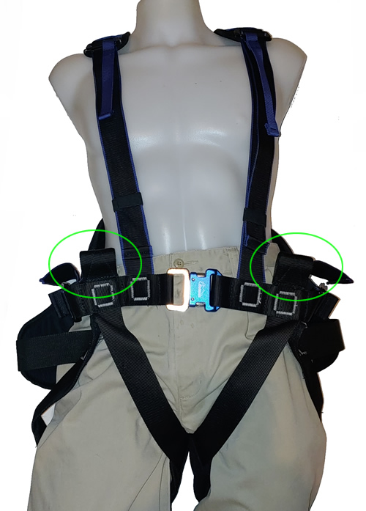

**Safety**

All riders must maintain an upright position (if the riders inverts, although difficult, they may be able to fall out of the harness). After each fall or impact the harness must be fully inspected for any damage, this includes times when the harness may come in contact with any corrosive chemicals. Recheck all buckles before connecting to the trolley system. During normal use they may loosen up.

**This harness cannot be used as a fall arrest harness.**

**Warning:**

The gear loop is not strong enough to use hold a rider,but is meant to hold small objects (camera, water bottle).

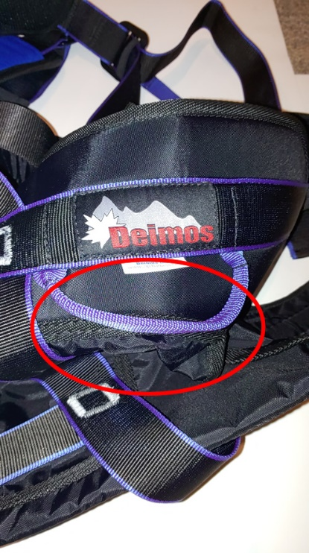

**Lifespan**

Each harness has been designed to operate for up to a maximum of ten years (if undamaged), however a single fall or exposure to harsh chemicals may require that the harness be retired immediately. Pitted rust on any of the metal parts will require the harness to be retired. Once the protective material on the hard points have been damaged and the black webbing is now exposed, then the harness must be retired.

**Transportation and Storage**

Mold can start to grow on the webbing if left wet. Harnesses should be stored away from sunlight and in a cool dry location. For transportation they should be in a plastic bag.

If mold is discovered on the harness then it must be retired.

**Sand, Ice and Snow**

In rare occasions, a grain of sand, ice or snow can prevent the waist buckles for locking fully. They should be tested prior to using.

Please contact Deimos Zip Harness if you have any questions.